MONTHS OF THE YEAR
(Meseci v letu)
1. Put into the correct order. Oštevilči mesece od 1-12.
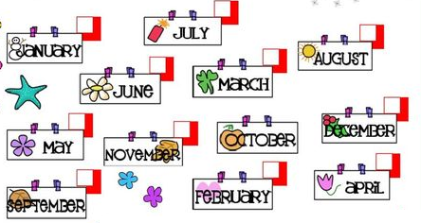
2. Match. Poveži mesece z ustreznimi sličicami.
JANUARY
APRIL
JULY
NOVEMBER
DECEMBER
FEBRUARY

3. What month is missing? Zapiši manjkajoči mesec.

JANUARY ____________________ MARCH
JUNE___________________AVGUST
NOVEMBER_______________________JANUARY
APRIL_______________________JUNE

4. What month is it? Kateri mesec je? Premešaj črke ter ugotovi mesec. Zapiši ga na črto.

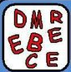

5. What is your favourite month? Kateri je tvoj najljubši mesec?
Nariši ga in ga poimenuj!

My favourite month is _____________________________

