MY FAMILY (MOJA DRUŽINA)

FATHER- MAMA  MOTHER- OČE  SISTER- SESTRA  BROTHER- BRAT | GRANDMOTHER- BABICA  GRANDFATHER- DEDEK | AUNT- TETA  UNCLE- STRIC  COUSIN- SESTRIČNA, BRATRANEC

1. WRITE THE NUMBERS. ZAPIŠI ŠTEVILA V PRAZNE SRČKE.

FATHER  MOTHER  COUSIN | 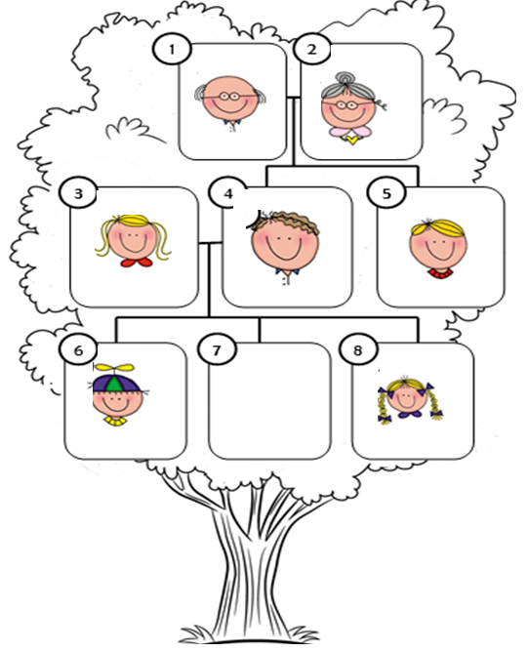 | UNCLE  AUNT  BROTHER
SISTER

GRANDFATHER GRANDMOTHER

2. WHO IS THIS? KDO JE TO? ZAPIŠI.
A FATHER | _______________ | _______________
_______________ | _______________ | _______________

3. CIRCLE. OBKROŽI PRAVILNO POVED.
THIS IS THIS IS  MY MOTHER. MY FATHER. | 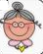  THIS IS THIS IS  MY BROTHER. MY GRANDMOTHER.

4. FIND PAIRS. POIŠČI PARE.
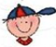  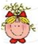 | GRANDFATHER  UNCLE  MOTHER  BROTHER  COUSIN  ME

