DAYS, MONTHS, SEASONS
(dnevi, meseci, letni časi)
1. WHICH MONTH IS IT? Izračunaj. Številka, ki jo dobiš, pomeni določen mesec. Zapiši ga v prazen okvirček. Pr. če dobiš 5, pomeni peti mesec, torej maj (MAY).
6  +45  -39 | 23  -17  + 4 | 99  -68  -25  + 1

2. SEASONS. Poveži letne čase.
 |  | 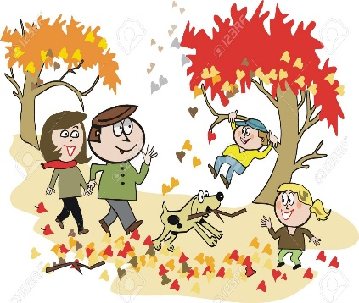
SPRING | SUMMER | AUTUMN | WINTER

3. WHAT IS THE WEATHER LIKE? Opiši vreme in poleg nariši.

What’s the weather like in September?  It is windy and…… | What’s the weather like in March?
What’s the weather like in December? | What’s the weather like in June?

