WHAT IS THE TIME, PLEASE?

1. What is the time? Koliko je ura? Zapiši. Glej primer!!
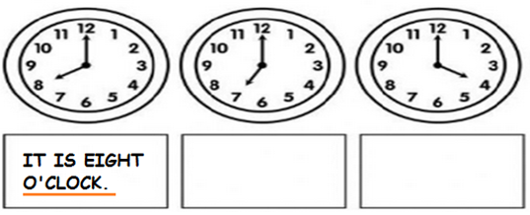
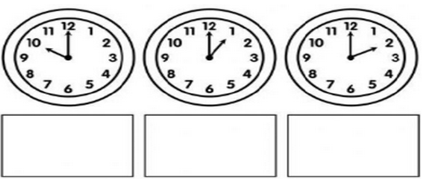

2. Write the time. Nariši ustrezen čas. Nariši kazalce.

IT IS FOUR O'CLOCK. | IT IS NINE O'CLOCK. | IT IS THREE O'CLOCK.
IT IS ELEVEN O'CLOCK. | IT IS FIVE O'CLOCK. | IT IS ONE O'CLOCK.

3. Match. Poveži.
 | 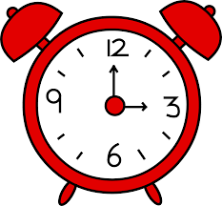
It is three o'clock. | 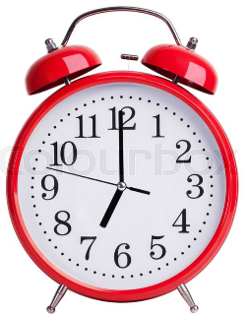 | It is six o'clock.
Iis twelve o'clock. | 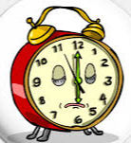 | It is seven o'clock.
 | 