BODY - TELO
HAIR-LASJE  NOSE- NOS  NECK-VRAT | EAR- UHO  MOUTH- USTA  EYE- OKO  HAND-DLAN | ARM- ROKA  FOOT-STOPALO  LEG- NOGA

1. LABEL THE BODY PARTS. POVEŽI DELE TELESA.
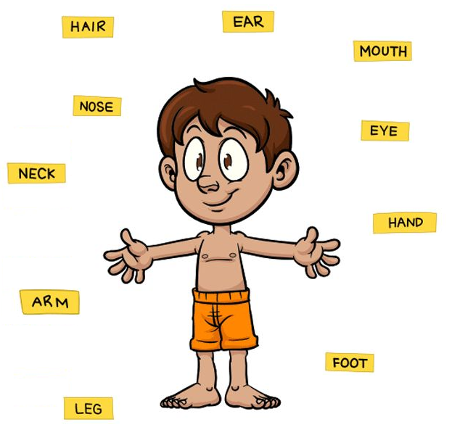

2. CIRCLE THE WORD. OBKROŽI USTREZNO SLIČICO.
EAR
HAIR
ARM
MOUTH

3. HOW MANY? KOLIKO? PREŠTEJ IN ŠTEVILKO ZAPIŠI Z BESEDO.
HOW MANY LEGS? | HOW MANY EYES? | HOW MANY TEETH?

4.READ AND COLOUR. PREBERI IN PRAVILNO POBARVAJ POŠASTKA.
HELLO! I AM GONZO. I HAVE GOT 2 RED EYES, 5 BLUE TEETH, 2 ORANGE LEGS, 2 GREEN EARS AND 1 PINK BODY. MY ARMS ARE YELLOW. | 