**CLOTHES**

**1. KAKŠNE BARVE SO OBLAČILA, KI JIH VIDIŠ NA SLIKI? ZAPIŠI NA ČRTE.**

|  |  |
| --- | --- |
| Povezana slika | ________________BOOTS  ______________TROUSERS  ___________________HAT  __________________DRESS  _________________PULLOVER  _________________SCARF |

**2. DRAW THE CLOTHES. PREBERI TER NARIŠI OBLAČILA IN S TEM OBLEČI LISO IN TOMA.**

|  |  |
| --- | --- |
| **LISA:**  BIG YELLOW HAT  ORANGE SKIRT  BROWN BOOTS  GREEN T-SHIRT | **TOM:**  BLUE CAP  RED AND YELLOW T-SHIRT  BLUE SHORTS  ORANGE SOCKS  PURPLE SHOES |

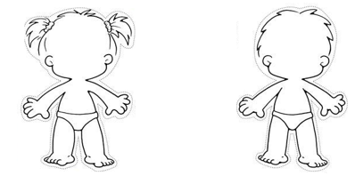

**3. WRITE THE NUMBERS. ZAPIŠI ŠTEVILKE.**

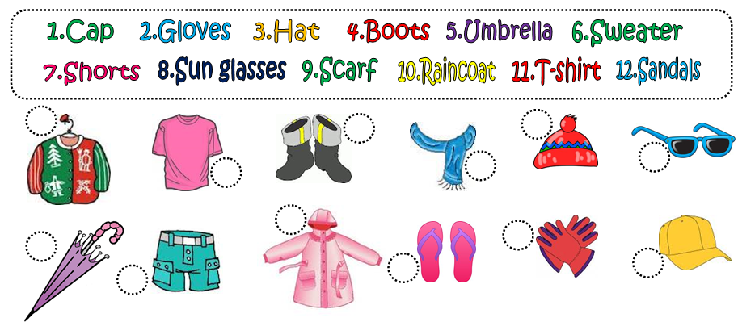

**4. WRITE 3 WINTER AND 3 SUMMER CLOTHES. ZAPIŠI 3 ZIMSKA IN 3 LETNA OBLAČILA.**

|  |  |
| --- | --- |
| [https://encrypted-tbn0.google.com/images?q=tbn:ANd9GcRHaW7qUu6gwdItjapoCV6BUQpgJmuru0U4IhVEqQkhsKABuLsFHg](http://www.google.com.tr/imgres?hl=tr&sa=X&biw=1366&bih=613&tbm=isch&prmd=imvns&tbnid=48zArKTyLn-o7M:&imgrefurl=http://seasons.phillipmartin.info/seasons_winter.htm&docid=vZdOAECTkG8iaM&imgurl=http://seasons.phillipmartin.info/seasons_winter.gif&w=648&h=637&ei=b5YlT9LaF8TVtAa0vIX4Bg&zoom=1) | http://seasons.phillipmartin.info/seasons_summer_sand.gif |
| __________________________  __________________________  __________________________ | __________________________  __________________________  __________________________ |